Fort Nelson Petroleum Association
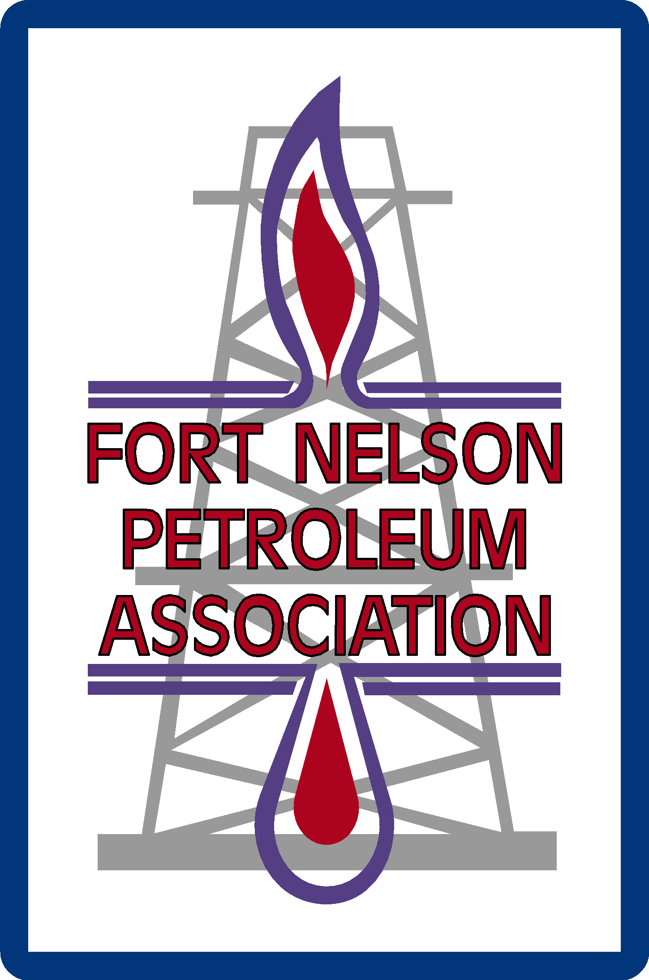
50th Annual Oilmen’s Curling Bonspiel
March 20 – 23, 2024
Fort Nelson Curling Club

February 2024

The 50th Annual Fort Nelson Petroleum Association Curling Bonspiel is back, and scheduled for
March 20 – 23, 2024. Here are just some of the reasons why your company should continue to be part of Fort Nelson’s most anticipated curling event:

- Exposure to an expected 80+ curlers, including members of the Fort Nelson Petroleum Industry and their associates,
- Exposure to other Petroleum-Industry related companies
- Opportunity to attend Bonspiel functions
- Support the Petroleum Association, an organization that has donated over $100,000 to the community, thanks to the contributions of local industry and related businesses, and
- The prestige associated with supporting the Fort Nelson Petroleum Association’s longest-running event!

Sponsorship spots sell out quickly, so please confirm your participation as soon as possible by contacting the Bonspiel Administrator, or by completing & returning the attached sponsor registration form. In order to ensure all Sponsorship fulfillment promises are met, we would appreciate your response by March 1, 2024.

Thank you for your consideration! We hope to see your company represented at the Bonspiel, and please don’t hesitate to call if you have any questions.

For additional forms and information on the 50th Annual Fort Nelson Oilmen’s Curling Bonspiel, visit our website http://www.fortnelsonpetroleumassociation.com/Events.html.

Sincerely,

Louise Schindler
Bonspiel Administrator
Fort Nelson Petroleum Association
250-775-1451
mailto:glschindler57@gmail.com

Fort Nelson Petroleum Association
50th Annual Fort Nelson Oilmen’s Curling Bonspiel
March 20 - 23, 2024

Sponsor Registration Form

Sponsorship Category:
Sponsor Company Name:
Contact Person:
Mailing Address:
City: |  |  |  | Postal Code:
Phone: |  |  |  | Cell:
Email: |  |  |  | Fax:
Size:

 | Total Sponsorship Cost: | $

*Dinner Banquet tickets in addition to those included in some sponsorships will go on sale once event begins

Payment Method: |  | Cheque |  | Cash |  |  | P.O. #
 |  | Visa |  | Mastercard
Credit Card #: |  |  |  |  |  | Expiry Date:
Name on Card:
CVV#:

*We will be in touch with you if we don’t already have a colour copy of your company logo on file.

Signature: ____________________________________________________
(Required to validate credit card purchase)

* Email registration form to mailto:glschindler57@gmail.com or mail to PO Box #1141, Fort Nelson, BC V0C1R0.
Fort Nelson Petroleum Association
50th Annual Oilmen’s Curling Bonspiel
March 20 – 23, 2024
Fort Nelson Curling Club

General Schedule of Events

Wednesday, March 20th
Registration
Welcome Reception
Crib Tournament Starts

Thursday, March 21st
Curling Starts
Complimentary Dinner Banquet

Friday, March 22nd
Breakfast by Donation
Host Bar
Curling
Turkey Barbeque Lunch
Steak Supper
Elimination Draw
Auction

Saturday, March 23rd
Breakfast by Donation
Host Bar
Curling
Turkey Barbeque Lunch
Closing Buffet Wind Up
Prize & Trophy Presentations

