Fort Nelson Petroleum Association
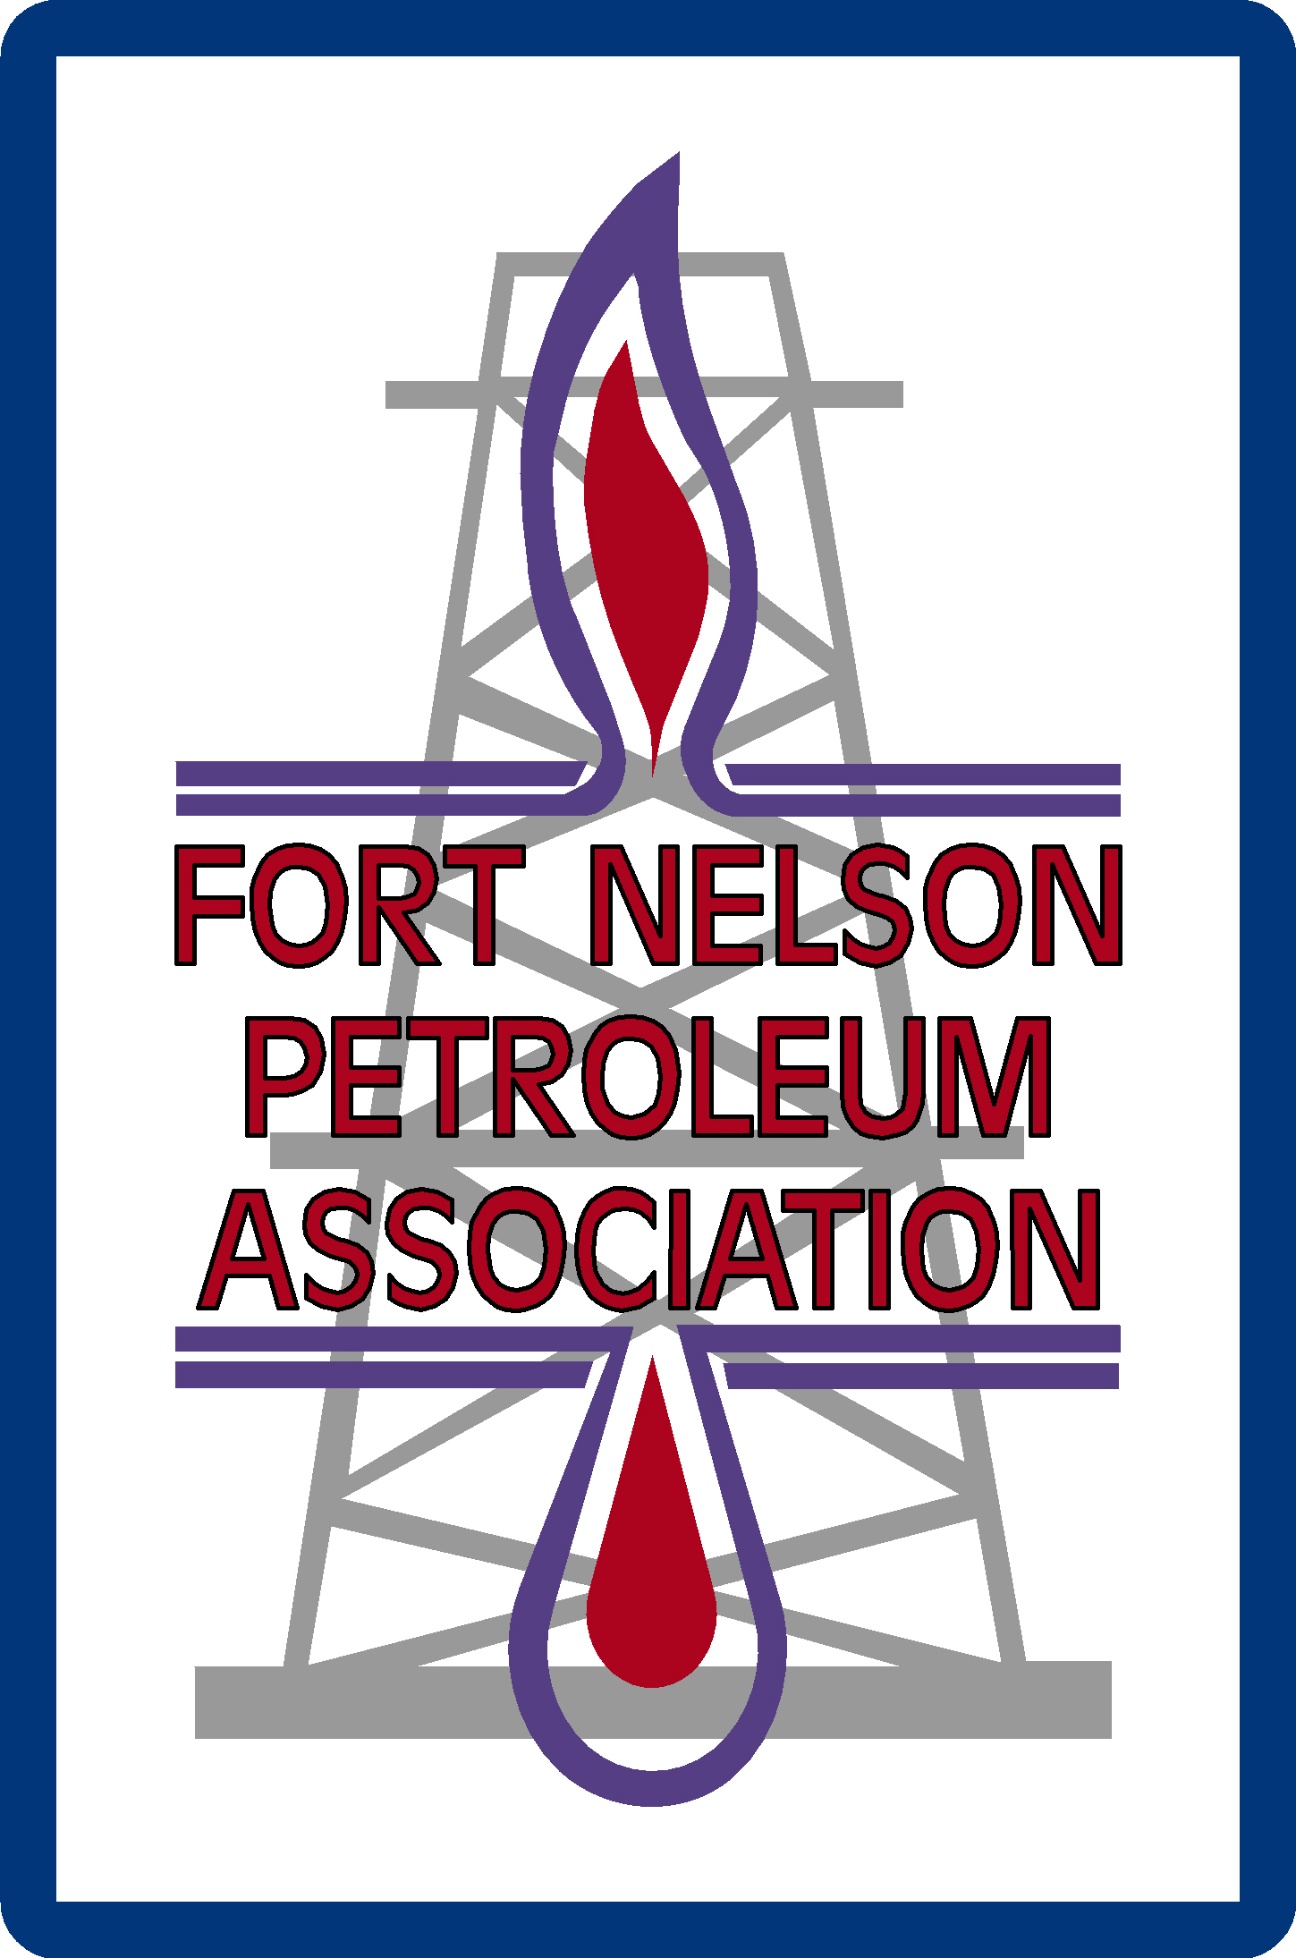
45th Annual Oilmen’s Curling Bonspiel
March 15 – 18, 2017
Fort Nelson Curling Club

November 2016

The 45th Annual Fort Nelson Petroleum Association Curling Bonspiel is back, and scheduled for
March 15 – 18, 2017. Here are just some of the reasons why your company should continue to be part of Fort Nelson’s most anticipated curling event:

- Exposure to an expected 120+ curlers, including members of the Fort Nelson Petroleum Industry and their associates,
- Exposure to other Petroleum-Industry related companies
- Opportunity to attend Bonspiel functions
- Support the Petroleum Association, an organization that has donated over $100,000 to the community, thanks to the contributions of local industry and related businesses, and
- The prestige associated with supporting the Fort Nelson Petroleum Association’s longest-running event!

Enclosed in this package are the sponsorship opportunities available for 2017, including the specific benefits your company will receive with each opportunity.

Sponsorship spots sell out quickly, so please confirm your participation as soon as possible by contacting the Bonspiel Administrator, or by completing & returning the attached sponsor registration form. In order to ensure all Sponsorship fulfillment promises are met, we would appreciate your response by March 10, 2017.

Thank you for your consideration! We hope to see your company represented at the Bonspiel, and please don’t hesitate to call if you have any questions.

For additional forms and information on the 45th Annual Fort Nelson Oilmen’s Curling Bonspiel, visit our website www.fortnelsonpetroleumassociation.com/events.

Sincerely,

Louise Schindler
Executive Director FNPA
250-775-1451
fnoilmans@gmail.com

Fort Nelson Petroleum Association
45th Annual Fort Nelson Oilmen’s Curling Bonspiel
March 15 – 18, 2017

Sponsor Registration Form

Sponsorship Category:
Sponsor Company Name:
Contact Person:
Mailing Address:
City: |  |  |  | Postal Code:
Phone: |  |  |  | Cell:
Email: |  |  |  | Fax:
Size:

 | Total Sponsorship Cost: | $

*Dinner Banquet tickets in addition to those included in some sponsorships will go on sale once event begins

Payment Method: |  | Cheque |  | Cash |  |  | P.O. #
 |  | Visa |  | Mastercard
Credit Card #: |  |  |  |  |  | Expiry Date:
Name on Card:
CVV#:

*We will be in touch with you if we don’t already have a colour copy of your company logo on file.

Signature: ____________________________________________________
(Required to validate credit card purchase)

* Email registration form to fnoilmans@gmail.com , fax to (250) 774-7065, or mail to P.O. Box # 1141, Fort Nelson, B.C. V0C 1R0.
Fort Nelson Petroleum Association
45th Annual Oilmen’s Curling Bonspiel
Mar 15 – 18, 2017
Fort Nelson Curling Club

General Schedule of Events

Wednesday, March 15th
Registration Welcome Reception
Curling Begins

Thursday, March 16th
Breakfast by Donation Curling Continues

Friday, March 17th
Breakfast by Donation
Complimentary Dinner Banquet Elimination Draw

Saturday, March 18th
Breakfast by Donation Windup
Closing Reception Prize & Trophy Presentations

NOTE:

Some sponsorship benefits and our ability to display signage may have to be limited due to facility size and continued issues evolving with the Recreation Centre and Curling Lounge area.

All efforts will be made to provide the maximum exposure possible.

We appreciate your understanding of this year’s organizational challenges and especially appreciate your continued support of this great event.

